CYCLE 2 – PART 2

- Create a square matrix with random integer values(use randint()) and use appropriate functions to find:
i) inverse
ii) rank of matrix
iii) Determinant
iv) transform matrix into 1D array
v) eigen values and vectors

Code:

import numpy as np
print("Matrix:")
ar = np.random.randint(10, size=(3, 3))
print(ar)

print("\n Inverse Matrix:")
print(np.linalg.inv(ar))

print("\n Rank of Matrix:")
print(np.linalg.matrix_rank(ar))

print("\n Determinant:")
print(np.linalg.det(ar))

print("\n Transform matrix into 1D array:")
print(np.ravel(ar))

print("\n Eigen values and vectors:")
print(np.linalg.eig(ar))

Output:

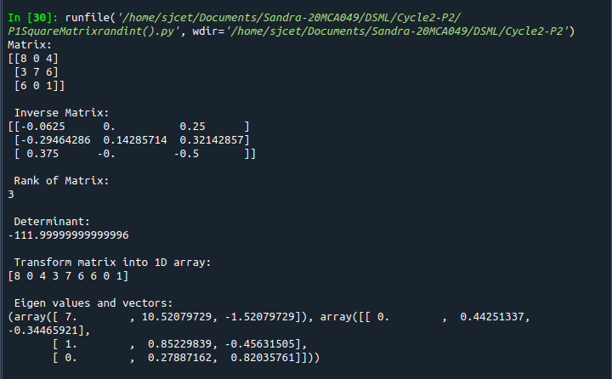

2. Create a matrix X with suitable rows and columns
i) Display the cube of each element of the matrix using different methods
(use multiply(), *, power(),**)
ii) Display identity matrix of the given square matrix.
iii) Display each element of the matrix to different powers.
iv) Create a matrix Y with same dimension as X and perform the operation X²+2Y

Code:

import numpy as np
x=np.arange(1,10).reshape(3,3)
print("Matrix:\n ",x)

print("Cube using multiply():\n",np.multiply(x,3))

print("Cube using * :\n ",x*x*x)

print("Cube using power():\n",np.power(x,3))

print("Cube using ** :\n",x**3)

print("Identity matrix of the given square matrix:")
print(np.identity(3,dtype= int))

print(" Display each element of the matrix to different powers.")
print(np.power(x,x))

print("Create a matrix Y with same dimension as X and perform the operation X2+2Y:",)
y = np.arange(11,20).reshape(3,3)
print(np.add((np.power(x,2)),(np.multiply(y,2))))
Output:

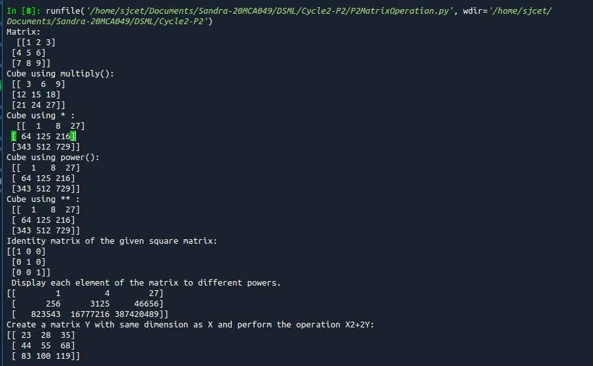

- Multiply a matrix with a submatrix of another matrix and replace the same in larger matrix.
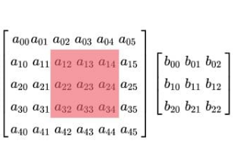

Code:

import numpy as np;

x = np.arange(1,31).reshape(5,6)
print("\n x-> big matrix :\n",x)
#x[column,row]
y=x[1:4,2:5]
#print("y-> sub matrix of x : \n",y)
z = np.arange(2,11).reshape(3,3)
#print("matrix z :\n",z)
y = np.multiply(y,z)
#print("multiplied matrix : \n",y)

x[1:4,2:5] = y
print("\n final replaced matrix:\n ",x)

Output:

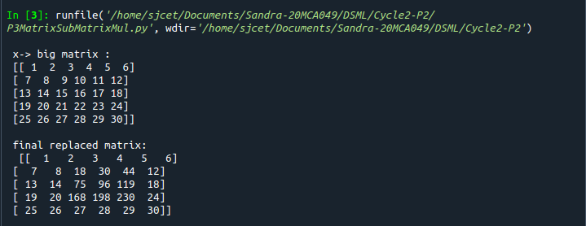

- Given 3 Matrices A, B and C. Write a program to perform matrix multiplication of the 3 matrices.
Code:

import numpy as np

A = ([1, 1, 1],[1 ,1, 1],[1, 1, 1])
B = ([1, 1, 1],[1 ,1, 1],[1, 1, 1])
C = ([1, 1, 1],[1 ,1, 1],[1, 1, 1])

res = np.dot(A,np.dot(B,C))

print("\n Product Of Matrices: \n\n", res)

Output:
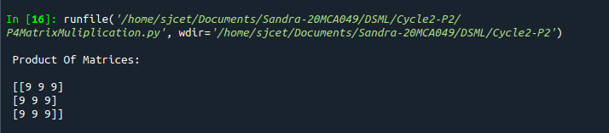

- Write a program to check whether given matrix is symmetric or Skew Symmetric.

Code:

import numpy as np;
x = np.arange(1,10).reshape(3,3)
print("Matrix x: \n", x)
# Transposing the Matrix M
y=x.transpose();
print("Transpose of x :\n ",y)
# -1(Transpose)
skew=np.multiply(y,-1);
print("negative of transpose :\n ",skew)
if x.all() == y.all():
print("Matrix is symmetric")
else:
print("Matrix is not symmetric")
if x.all() == ~y.all():
print("Matrix is skew symmetric")
else:
print("Matrix is not skew matrix")
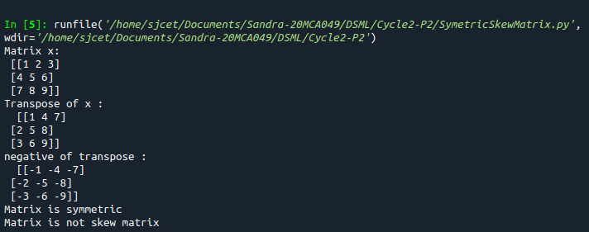
Output:

- Write a program to find out the value of X using solve(), given A and b as above
Code:

import numpy as np;
A=np.array([[2,1,-2],[3,0,1],[1,1,-1]])
b=np.array([[-3],[5],[2]])
print("A:\n",A)
print("b:\n",b)
X=np.multiply((np.linalg.inv(A)),b)
print("X is : \n",X)
Output:
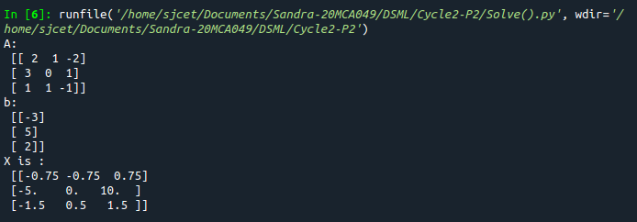

- Write a program to perform the SVD of a given matrix. Also reconstruct the given matrix from the 3 matrices obtained after performing SVD.

Code:

import numpy as np;
A = np.array([[1, 2], [3, 4], [5, 6]])
print("Matrix:\n",A)
# SVD
U, s, VT = np.linalg.svd(A)
print("U:\n", U)
print("Sigma:\n",s)
print("V^T:\n",VT)

Output:

